Plane and Line

Definition
# Source: AI Source: Provided by: [Data Path: Persons Table -> ID Column: 1, Name_En Column: Motasem Essam] -> From: [ChatGPT] on [7/25/2026]
The relationship between a plane and a line in solid geometry describes how a straight line is positioned relative to a plane in three-dimensional space.
A line and a plane can have three fundamental relationships:
- Line contained in a plane: Every point on the line belongs to the plane.
- Line parallel to a plane: The line and plane have no common points.
- Line intersecting a plane: The line and plane share exactly one point.
A perpendicular line is a special type of intersecting line that meets the plane at a right angle of ${90}^{∘}$.
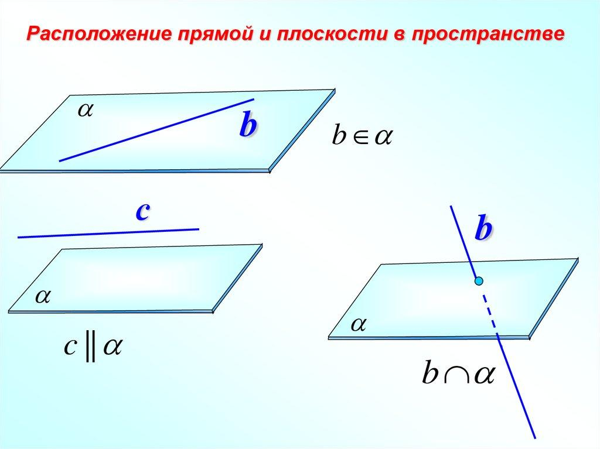
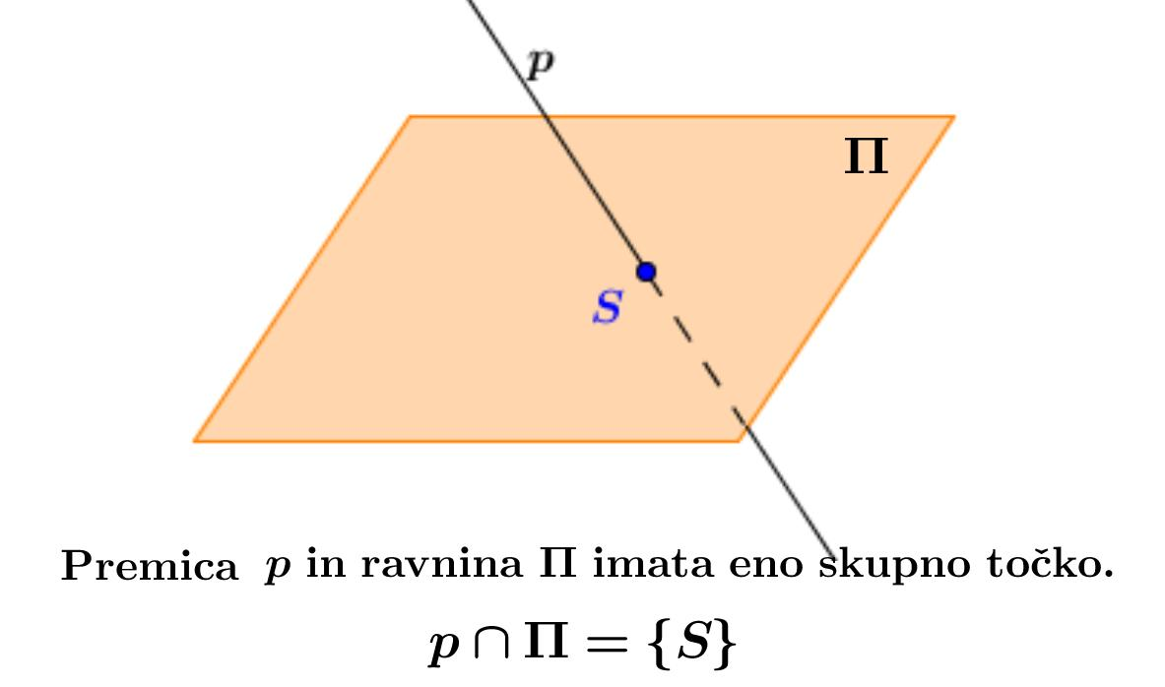
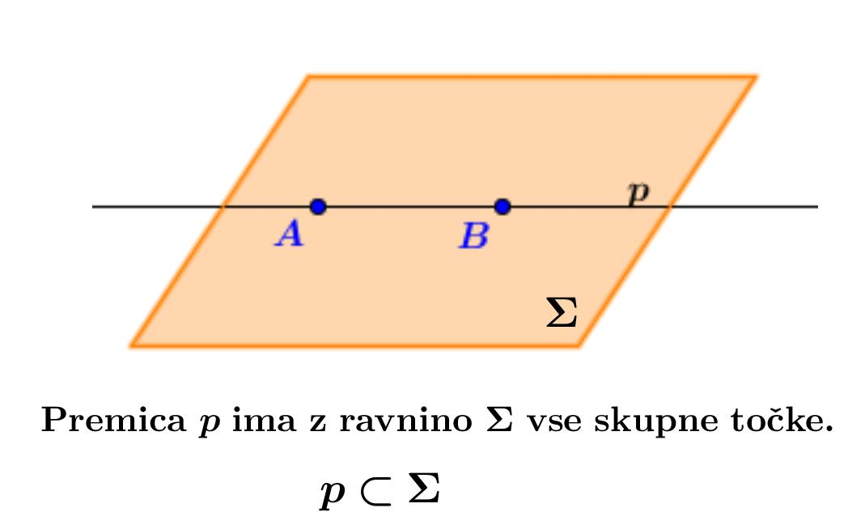

Simple Definition
# Source: AI Source: Provided by: [Data Path: Persons Table -> ID Column: 1, Name_En Column: Motasem Essam] -> From: [ChatGPT] on [7/25/2026]
The relationship between a plane and a line tells us whether the line lies on the plane, stays separate from it, or crosses it.
Examples include:
- A line drawn on a flat tabletop is contained in the plane of the tabletop.
- A straight line above a tabletop, running parallel to its surface, is parallel to the plane.
- A vertical pole passing through a horizontal floor intersects the plane of the floor.
These examples treat physical surfaces as ideal mathematical planes and physical objects as ideal lines where appropriate.

Types of Relationships Between a Plane and a Line
# Source: AI Source: Provided by: [Data Path: Persons Table -> ID Column: 1, Name_En Column: Motasem Essam] -> From: [ChatGPT] on [7/25/2026]
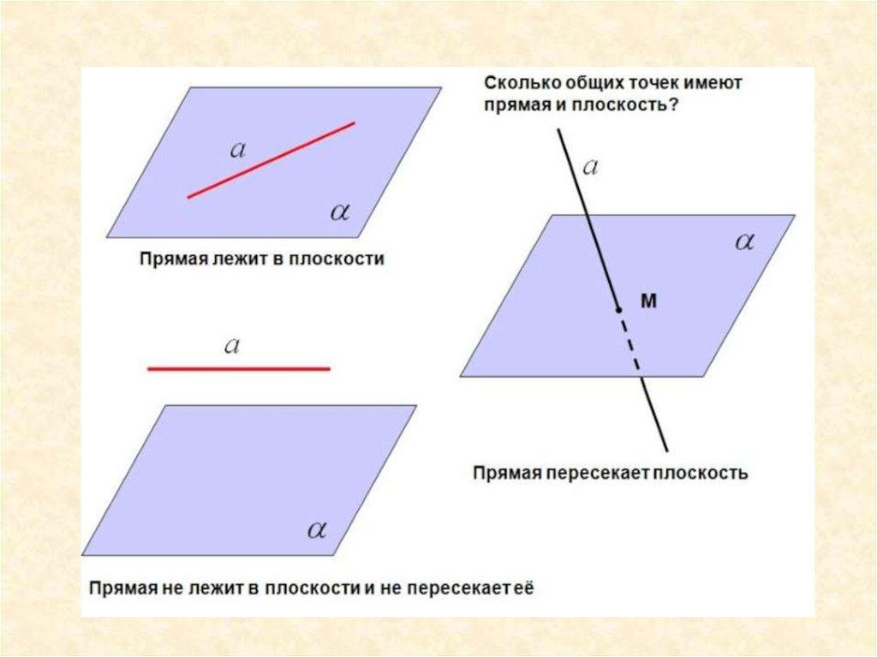

1. Line Contained in a Plane
# Source: AI Source: Provided by: [Data Path: Persons Table -> ID Column: 1, Name_En Column: Motasem Essam] -> From: [ChatGPT] on [7/25/2026]
Every point on the line lies on the plane. The line and plane share infinitely many points.
$$L⊂α$$

2. Line Parallel to a Plane
# Source: AI Source: Provided by: [Data Path: Persons Table -> ID Column: 1, Name_En Column: Motasem Essam] -> From: [ChatGPT] on [7/25/2026]
The line remains a constant positive perpendicular distance from the plane and never intersects it.
$$L∩α=∅$$
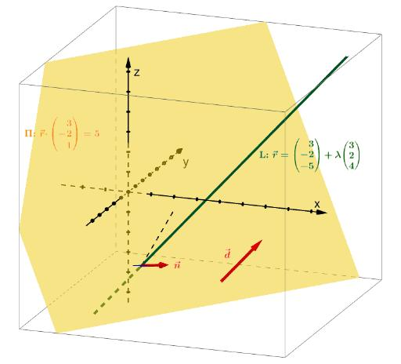

3. Line Intersecting a Plane
# Source: AI Source: Provided by: [Data Path: Persons Table -> ID Column: 1, Name_En Column: Motasem Essam] -> From: [ChatGPT] on [7/25/2026]
The line passes through the plane at exactly one point.
$$L∩α=\left\{P\right\}$$
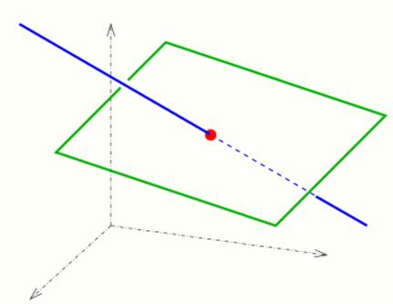

4. Line Perpendicular to a Plane
# Source: AI Source: Provided by: [Data Path: Persons Table -> ID Column: 1, Name_En Column: Motasem Essam] -> From: [ChatGPT] on [7/25/2026]
The line intersects the plane at ${90}^{∘}$. This is a special case of an intersecting line.
$$L⊥α$$
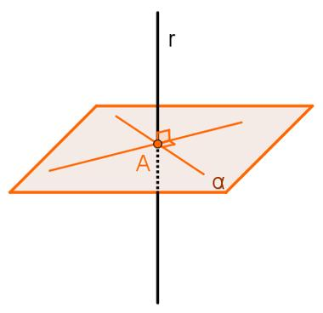

Key Characteristics
# Source: AI Source: Provided by: [Data Path: Persons Table -> ID Column: 1, Name_En Column: Motasem Essam] -> From: [ChatGPT] on [7/25/2026]
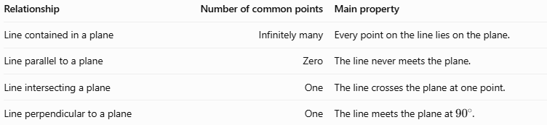
Relationship | Number of common points | Main property
Line contained in a plane | Infinitely many | Every point on the line lies on the plane.
Line parallel to a plane | Zero | The line never meets the plane.
Line intersecting a plane | One | The line crosses the plane at one point.
Line perpendicular to a plane | One | The line meets the plane at ${90}^{∘}$.

Mathematical Representation

General equation of a plane
# Source: AI Source: Provided by: [Data Path: Persons Table -> ID Column: 1, Name_En Column: Motasem Essam] -> From: [ChatGPT] on [7/25/2026]
A plane in three-dimensional Cartesian coordinates is represented by
$$Ax+By+Cz+D=0$$
Its normal vector is
$$n=\left(A,B,C\right)$$
The normal vector is perpendicular to every direction lying within the plane.

Parametric equation of a line
# Source: AI Source: Provided by: [Data Path: Persons Table -> ID Column: 1, Name_En Column: Motasem Essam] -> From: [ChatGPT] on [7/25/2026]
A line can be represented by
$$r=r_{0}+tv$$
where:
- $r_{0}=\left(x_{0},y_{0},z_{0}\right)$ is a point on the line.
- $v=\left(a,b,c\right)$ is its direction vector.
- $t∈R$ is a parameter.
In coordinate form,
$$\begin{aligned}x&=x_{0}+at \\ y&=y_{0}+bt \\ z&=z_{0}+ct\end{aligned}$$

Determining the relationship
# Source: AI Source: Provided by: [Data Path: Persons Table -> ID Column: 1, Name_En Column: Motasem Essam] -> From: [ChatGPT] on [7/25/2026]
Substitute the line's parametric equations into the plane equation:
$$A\left(x_{0}+at\right)+B\left(y_{0}+bt\right)+C\left(z_{0}+ct\right)+D=0$$
Rearranging gives
$$\underset{n⋅v}{\underbrace{\left(Aa+Bb+Cc\right)}}t+\underset{S}{\underbrace{\left(Ax_{0}+By_{0}+Cz_{0}+D\right)}}=0$$
This produces three possible cases.
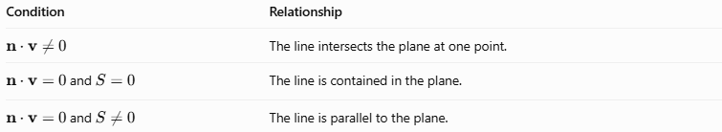
Condition | Relationship
$$n⋅v≠0$$ | The line intersects the plane at one point.
$n⋅v=0$ and $S=0$ | The line is contained in the plane.
$n⋅v=0$ and $S≠0$ | The line is parallel to the plane.
Here, $S$ is the plane equation evaluated at the point $r_{0}$.

Condition for perpendicularity
# Source: AI Source: Provided by: [Data Path: Persons Table -> ID Column: 1, Name_En Column: Motasem Essam] -> From: [ChatGPT] on [7/25/2026]
A line is perpendicular to a plane when its direction vector is parallel to the plane's normal vector.
$$\boxed{v=kn, k≠0}$$
Equivalently, the line's direction vector must be a nonzero scalar multiple of $\left(A,B,C\right)$.
The line then intersects the plane at a right angle.

Worked Examples
# Source: AI Source: Provided by: [Data Path: Persons Table -> ID Column: 1, Name_En Column: Motasem Essam] -> From: [ChatGPT] on [7/25/2026]
Example 1: A line contained in a plane
Determine the relationship between
$$L:\left(x,y,z\right)=\left(1,2,0\right)+t\left(1,-1,0\right)$$
and the plane
$$α:z=0$$
From the line equation,
$$x=1+t, y=2-t, z=0$$
Every point on the line has $z=0$, which satisfies the plane equation.
Answer: The line is contained in the plane.
Example 2: A line parallel to a plane
Consider
$$L:\left(x,y,z\right)=\left(0,0,3\right)+t\left(1,2,0\right)$$
and
$$α:z=0$$
Every point on the line has $z=3$, so it never satisfies $z=0$.
The line's direction vector $\left(1,2,0\right)$ is perpendicular to the plane's normal vector $\left(0,0,1\right)$:
$$\left(1,2,0\right)⋅\left(0,0,1\right)=0$$
Thus, the line is parallel to the plane. Its perpendicular distance from the plane is $3$ units.
Example 3: A line intersecting a plane
Consider
$$L:\left(x,y,z\right)=\left(1,0,0\right)+t\left(0,0,1\right)$$
and
$$α:x+y+z-4=0$$
Substitute the line's coordinates:
$$1+0+t-4=0$$
$$t=3$$
The intersection point is
$$\boxed{P=\left(1,0,3\right)}$$
Answer: The line intersects the plane at exactly one point.
Example 4: A line perpendicular to a plane
Consider
$$L:\left(x,y,z\right)=\left(1,2,0\right)+t\left(2,3,6\right)$$
and
$$α:2x+3y+6z-10=0$$
The plane's normal vector is
$$n=\left(2,3,6\right)$$
The line's direction vector is also
$$v=\left(2,3,6\right)$$
Because $v=n$, the line is perpendicular to the plane.
To find their intersection, substitute the line into the plane equation:
$$2\left(1+2t\right)+3\left(2+3t\right)+6\left(6t\right)-10=0$$
$$4+49t=0$$
$$t=-\frac{4}{49}$$
The line meets the plane at the point corresponding to this parameter value.
Answer: The line intersects the plane perpendicularly at ${90}^{∘}$.

Comparison with Related Concepts
# Source: AI Source: Provided by: [Data Path: Persons Table -> ID Column: 1, Name_En Column: Motasem Essam] -> From: [ChatGPT] on [7/25/2026]
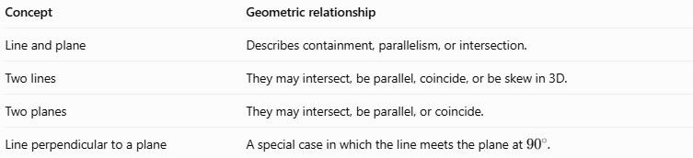
Concept | Geometric relationship
Line and plane | Describes containment, parallelism, or intersection.
Two lines | They may intersect, be parallel, coincide, or be skew in 3D.
Two planes | They may intersect, be parallel, or coincide.
Line perpendicular to a plane | A special case in which the line meets the plane at ${90}^{∘}$.

Applications
# Source: AI Source: Provided by: [Data Path: Persons Table -> ID Column: 1, Name_En Column: Motasem Essam] -> From: [ChatGPT] on [7/25/2026]
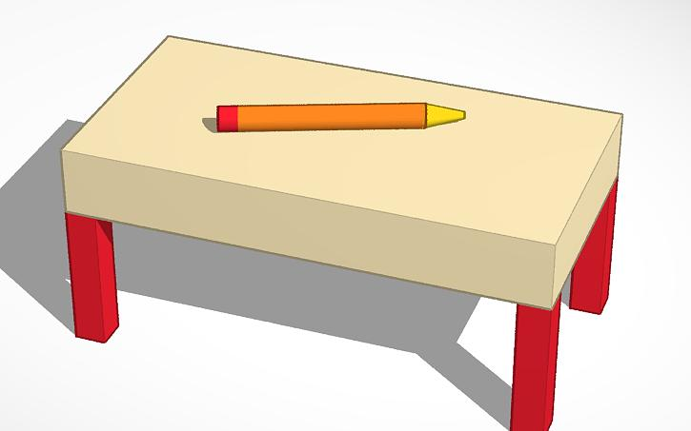
Geometry and measurement
Idealized straight objects help illustrate whether a line lies on a surface or crosses it.
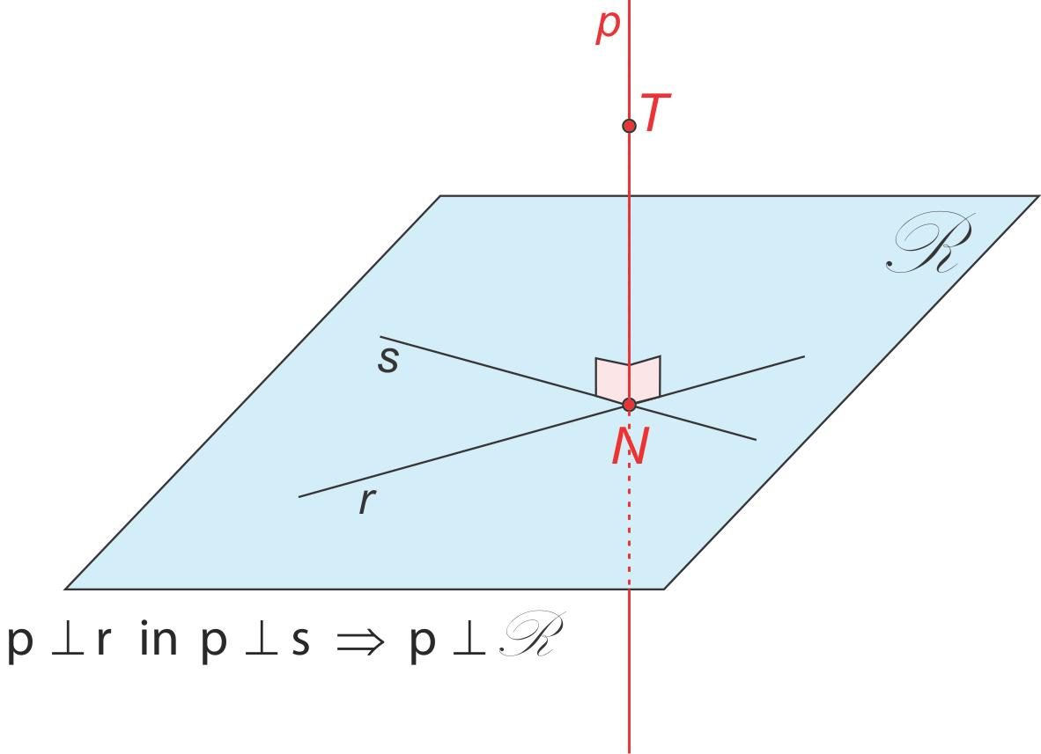
Construction and engineering
Perpendicular lines and surfaces are used to check vertical alignment, surface orientation, and structural geometry.
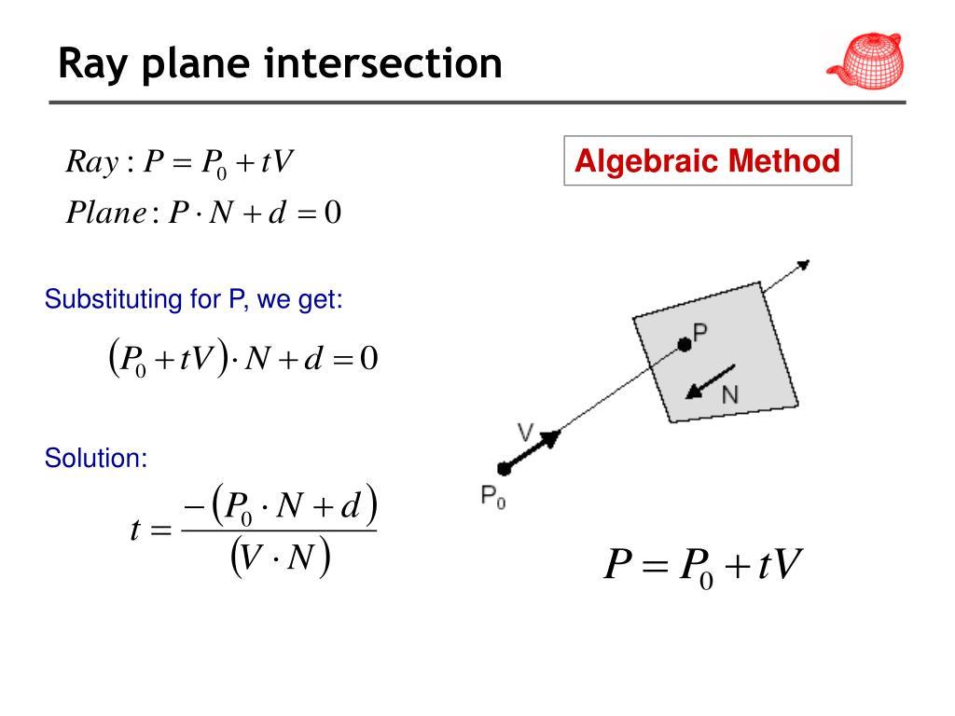
Computer graphics
Line-plane intersection calculations help determine where a ray or line reaches a surface in a 3D scene.

Key Points
# Source: AI Source: Provided by: [Data Path: Persons Table -> ID Column: 1, Name_En Column: Motasem Essam] -> From: [ChatGPT] on [7/25/2026]
- A line can lie in a plane, remain parallel to it, or intersect it at one point.
- A perpendicular line is a special type of intersecting line.
- The dot product between the line's direction vector and the plane's normal vector helps classify the relationship.
- If the dot product is nonzero, the line intersects the plane.
- If the dot product is zero, the line is either contained in the plane or parallel to it; substitute a point from the line to distinguish these cases.
- A perpendicular line has a direction vector parallel to the plane's normal vector.

Conclusion
# Source: AI Source: Provided by: [Data Path: Persons Table -> ID Column: 1, Name_En Column: Motasem Essam] -> From: [ChatGPT] on [7/25/2026]
The relationship between a plane and a line is determined by their relative positions and orientations. Using a plane equation, a line's parametric equation, and vector operations, we can determine whether the line is contained in the plane, parallel to it, or intersecting it. The perpendicular case adds the special condition of a ${90}^{∘}$ angle.

